1. How many orders were shipped by Speedy Express in total?

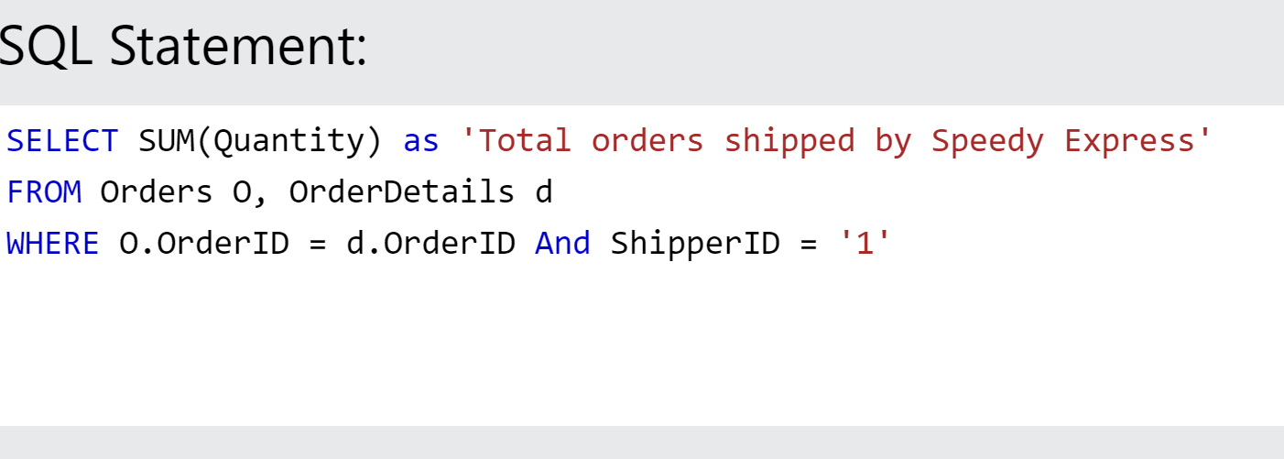

**RESULT:**

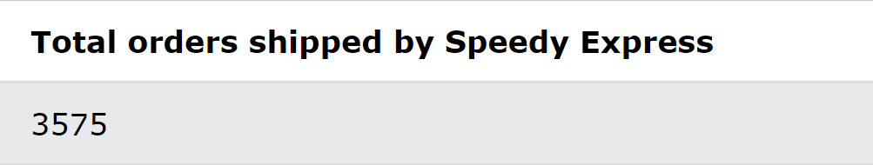

Code:

SELECT SUM(Quantity) as 'Total orders shipped by Speedy Express'

FROM Orders O, OrderDetails d

WHERE O.OrderID = d.OrderID And ShipperID = '1'

1. What is the last name of the employee with the most orders?

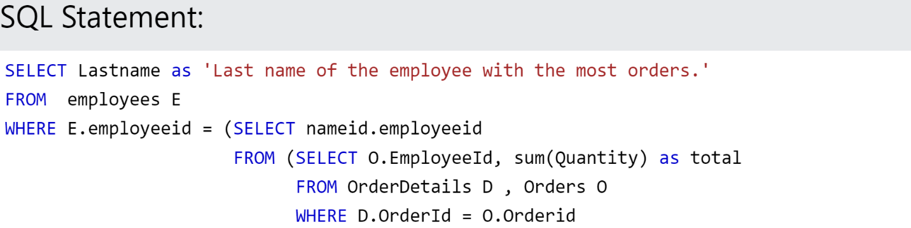



**RESULT:**

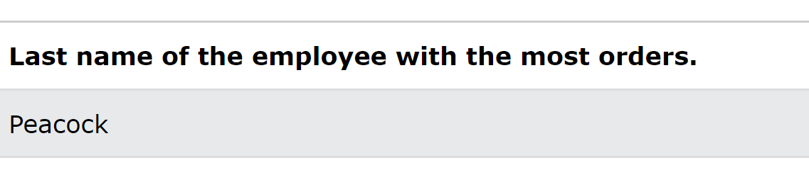

Code:

SELECT Lastname as 'Last name of the employee with the most orders.'

FROM employees E

WHERE E.employeeid = (SELECT nameid.employeeid

FROM (SELECT O.EmployeeId, sum(Quantity) as total

FROM OrderDetails D, Orders O

WHERE D.OrderId = O.Orderid

GROUP BY(O.EmployeeID)

ORDER BY total desc

LIMIT 1) nameid

)

1. What product was ordered the most by customers in Germany?

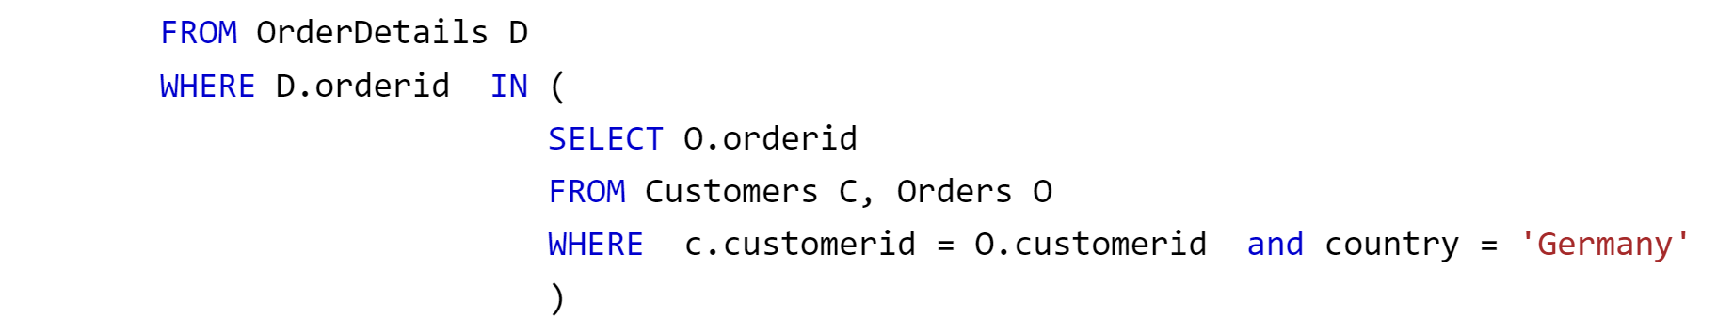

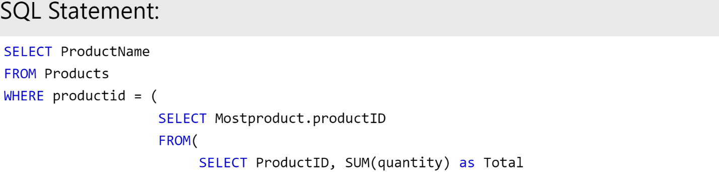

**RESULT:**

Code:

SELECT ProductName

FROM Products

WHERE productid = (

SELECT Mostproduct.ProductID

FROM (

SELECT ProductID, SUM (quantity) as Total

FROM OrderDetails D

WHERE D.orderid IN (

SELECT O.orderid

FROM Customers C, Orders O

WHERE c.customerid = O.customerid and country = 'Germany'

)

GROUP BY ProductID

ORDER BY Total DESC

LIMIT 1

)Mostproduct

)